BY TYLER S – AKA UNREALAGILITY

I. Introduction To Ti-Basic

ORIGINALLY THIS PROGRAMMING LANGUAGE WAS FOR PEOPLE TO MAKE MATHEMATICAL PROGRAMS, NOT FOR GAMES AND ALL THE OTHER STUFF YOU SEE TODAY. TI WANTED EVERYONE TO UNDERSTAND THIS LANGUAGE SO THEY MADE IT … AHHH WHAT’S THE WORD I’M LOOKING FOR? BASIC! IT COULDN’T HAVE BEEN ANY SIMPLER THAN IT IS NOW, EVERYONE SHOULD BE ABLE TO UNDERSTAND THIS LANGUAGE, AND ONCE YOU KNOW IT, IT’S VERY FUN AND HELPFUL (IN CLASS) BUT DEFINITELY NOT ON QUIZZES, NO CHEATERS HERE! =)
YOU’LL BE ABLE TO MAKE GAMES AND PROGRAMS OF ALL SORTS ONCE YOU BEGIN TO READ THIS MANUAL! DON’T RUSH THOUGH IT THINKING IT’S TO EASY BECAUSE IT WILL GET CONFUSING IF YOU SKIP AHEAD TO MUCH!

II. Table Of Contents

- CLEARING THE SCREEN
- DISPLAYING TEXT

- Clearing The Screen (ClrHome + ClrDraw)

CLRHOME AND CLRDRAW, WHAT’S THE DIFFERENCE YOU ASK. ONE CLEARS THE HOME-SCREEN, THE OTHER THE GRAPH-SCREEN. LETS BEGIN MAKING OUR FIRST PROGRAM. TO DO THIS WE GOTO THE HOME-SCREEN AND PRESS “PGRM” ON THE KEYPAD (IT’S NEXT TO “APPS”) AND YOU’LL SEE A MENU LIKE SO… (AT LEAST YOU SHOULD)

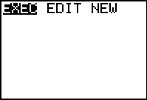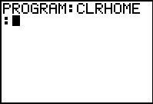

NEXT SLIDE ON OVER TO NEW BY PRESSING THE RIGHT ARROW KEY TWICE AND PRESS “ENTER”. YOU’LL BE PROMPTED TO ENTER IN A PROGRAM NAME, CALL THIS ONE CLRHOME AND PRESS “ENTER” AGAIN. YOU’LL GET A SCREEN LIKE ON THE RIGHT.
HERE COMES THE PROGRAMMING, DON’T WORRY IF YOU MESS UP, IT CAN’T SCREW UP YOUR CALC NO MATTER WHAT (EXCEPT FOR TI’S BUGS THAT YOU PURPOSELY TRY TO DO). PRESS PGRM AGAIN AND YOU’LL BE LOST IN THE FOLLOWING SCREEN. PRESS RIGHT ONCE AND GO DOWN TO 8 : CLRHOME

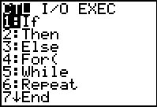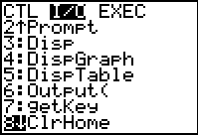

PRESS “ENTER AGAIN AND YOU’LL BE DONE WITH YOUR FIRST PROGRAM
, CONGRADULATIONS! NOW IF YOU HAVE AN IQ THAT ACCUTUALLY ALLOWED YOU TO DO THIS CORRECTLY YOU’LL PRESS “2ND” + “MODE” (QUIT) AND YOU’LL BE BACK AT THE HOMESCREEN. NOW PRESS “PGRM” AGAIN AND PRESS ENTER TWICE.

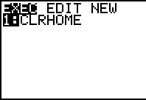

YOU SHOULD SEE THE FOLLOWING TWO SCREENS, THE ONE ON THE LEFT IN THE PROGRAM MENU AND THE ONE ON THE RIGHT AFTER YOU FINISH EXECUTING YOUR PROGRAM. IF YOU GET THE SCREEN UNDER THIS TEXT, YOU DID SOMETHING WRONG! CHECK YOUR CODE AND REPEAT THE STEPS ABOVE.

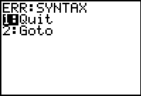

OTHERWISE YOU KNOW ONE COMMAND, HOW TO CREATE A PROGRAM, AND HOW TO RUN A PROGRAM, CONGRADULATIONS (TOLD YA IT WAS BASIC)!

- Displaying Text (Output( And Disp)

WELCOME BACK, THIS LESSON WE’LL BE DISPLAYING TEXT AND IT’S JUST AS EASY AS THE LAST. ALRIGHT CREATE ANOTHER PROGRAM AND CALL IT “DISPTEXT” AND OPEN THE “PGRM” MENU. INSERT THE CLRHOME COMMAND. PRESS ENTER FOR THE NEXT LINE! OPEN THE “PGRM” MENU AGAIN AND SLIDE THE CURSOR OVER RIGHT AND GO DOWN TO 6 : OUTPUT(. THEN TYPE 1,1,”DISPLAYING TEXT” RUN THAT PROGRAM AND LOOK AT THE TEXT!!

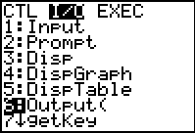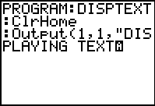

NOW YOU ARE PROBABILY WONDERING WHERE DOES THIS “1,1,” COME FROM AND WHAT IT ALL MEANS. WELL HERE’S MY CRAZY EXPLANATION. NOTICE HOW THERE ARE 8 CHARACTERS ABLE TO FIT ON A ROW, AND 16 PER COLUMN? WELL YOU COULD WRITE “OUTPUT(2,2,”DISPLAYING TEXT” AND YOU’D GET THIS INSTEAD OF THIS:

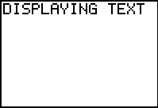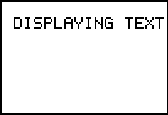

ARE YOU BEGINNING TO UNDERSTAND WHAT THIS DOES WELL HERE’S A BETTER PICTURE OF IT ALL

ROWS C O L U M N S

1 ; 1 2 3 4 5 6 7 8 9 10 11 12 13 14 15 16
2 ;
3 ;
4 ;
5 ;
6 ;
7 ;
8 ;

JUST REMEMBER ROW THEN COLUMN. CHECKUP QUIZ TIME! MAKE A PROGRAM CALLED “QUIZPG01” AND MAKE IT SO IT DISPLAYS “TEXT” ON ROW 7, COLUMN 12 (DON’T FORGET TO CLEAR THE HOME-SCREEN FIRST!)
LOOK DOWN FOR THE SOURCE CODE

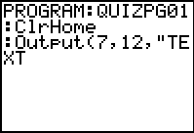

THAT’S ALL THERE IS TO IT, THIS IS PROBABILY THE HARDEST PART OF UNDERSTANDING BASIC ARE YOU CONFOUNDED OR WHAT!

I’LL GET THE NEXT TUTORIAL(S?) BY TOMORROW (APRIL 23RD, 2003)

